Classes Awards
a) Girder-fork rigid In addition to the best in
b) Tele-fork rigid each class ( a ) to ( j ) there
c) Two Stroke rigid will be a Premier Award for
d) Pre-unit springer the best overall performance on a
e) Unit construction 4 stroke Pre-65 machine for both routes, best
f) Two stroke springer Newcomer, best Manx Resident, best
g) Special Foreign Competitor, best Foreign
h) Twin-shock Modern Newcomer Award in classes
i) Under 35 Pre-65 (a ) to (f), best Clubman in class (h)
j) Under 35 Modern Twin Shock and First Class and
Finishers Awards

Riders entering classes g, h, i, j are only eligible for their class win, first class awards or finishers awards.

Competitors may ride the Premier or Clubman sections, except that classes a, b, c, will all ride the Clubman’s sections.

Past Winners:

1996 Premier Roy Wilson 200 Triumph Clubman Joe Morgan 350 Ariel
1997 Premier Roy Wilson 200 Triumph Clubman Bob Baker 350 Triumph
1998 Premier Peter Salt 250 Greeves Clubman W Holdsworth 175 Yamaha
1999 Premier K Chapman 350 Triumph Clubman David Emmott 350 AJS
2000 Premier Nic Draper 350 BSA Clubman Stan Cordingley 250 James
2002 Premier Peter Salt 250 Fran Barnett Clubman Stephen Collins 200 Triumph
2003 Premier K Chapman 350 Triumph Clubman Jim Davidson 250 BSA
2004 Premier John Maxfield 200 Triumph Clubman Ian Harland 410 AJS
2005 Premier Robin Luscombe 250 Triumph Clubman Paul Brimelow 246 James
2006 Premier Dave Thorpe 200 Triumph Clubman Carl Winstanley 250 F. Barn
2007 Premier John Maxfield 200 Triumph Clubman Eric Boocock 250 BSA
2008 Premier Dave Thorpe 200 Triumph Clubman Mathew Mison 500 AJS
2009 Premier John Maxfield 200 Triumph Clubman Mark Sturtevant 350 BSA
2010 Premier Juan Knight 250 Triumph Clubman Roger Callaghan 200 James
2011 Premier Juan Knight 250 Triumph Clubman Mark Sturtevant 250 James

Successful applicants will be sent details of how to obtain discounted travel and accommodation together with joining instructions.

Manx International Classic Trial
1st and 2nd September 2012

Organised by the
Manx Trials Club
www.ManxTrials.com

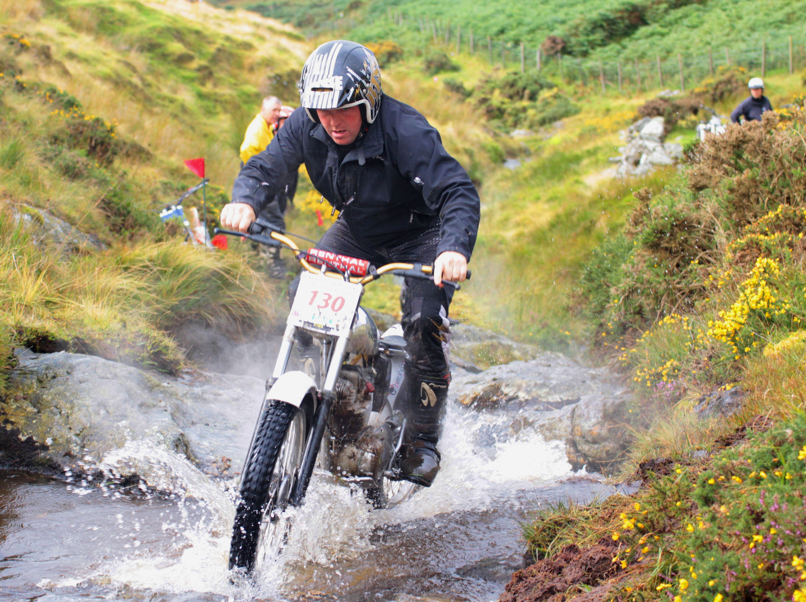

Juan Knight 250 Triumph Cub
Manx Classic Weekend Trial Winner 2011

